Game Design Document

Fill up the Following document

1. Write the title of your project?

Avanger: infnity stone

1. What is the goal of the game?

Goal of the game is to reach to the planet

1. Write a brief story of your game?

Thanos want to go to his planet as he have all the stone but stoped by the avangers

1. Which are the playing characters of this game?

* Playing characters are the ones which respond to the user based on the input from the user
* Cars, monkeys, dinos, wizards etc, are the playing characters in the game.

|  |  |  |
| --- | --- | --- |
| Number | Character Name | What can this character do? |
| 1 | thanos | Jump,move |
| 2 |  |  |
| 3 |  |  |
| 4 |  |  |
| 5 |  |  |
| 6 |  |  |
| 7 |  |  |
| 8 |  |  |

1. Which are the Non Playing Characters of this game?

* Non Playing characters are the ones which don't have an action or a behaviour when the user interacts with the game.
* Hurdles, stones, bananas, coins, etc are non playing characters in the game.

|  |  |  |
| --- | --- | --- |
| Number | Character Name | What can this character do? |
| 1 | spiderman | Shoot web |
| 2 | blackwidow | Shoot bullet |
| 3 | ironman | Shoot lasser |
| 4 | Hawkeye | Shoot arrow |
| 5 | Thor | Shot hammer |
| 6 | drStrange | Ues magic |
| 7 |  |  |
| 8 |  |  |

Draw your imagination of this game. What does this game look like?

* Draw the game either on your computer or on paper,
* Add images of scenes of the game to show each of the playing and non-playing characters at least once.

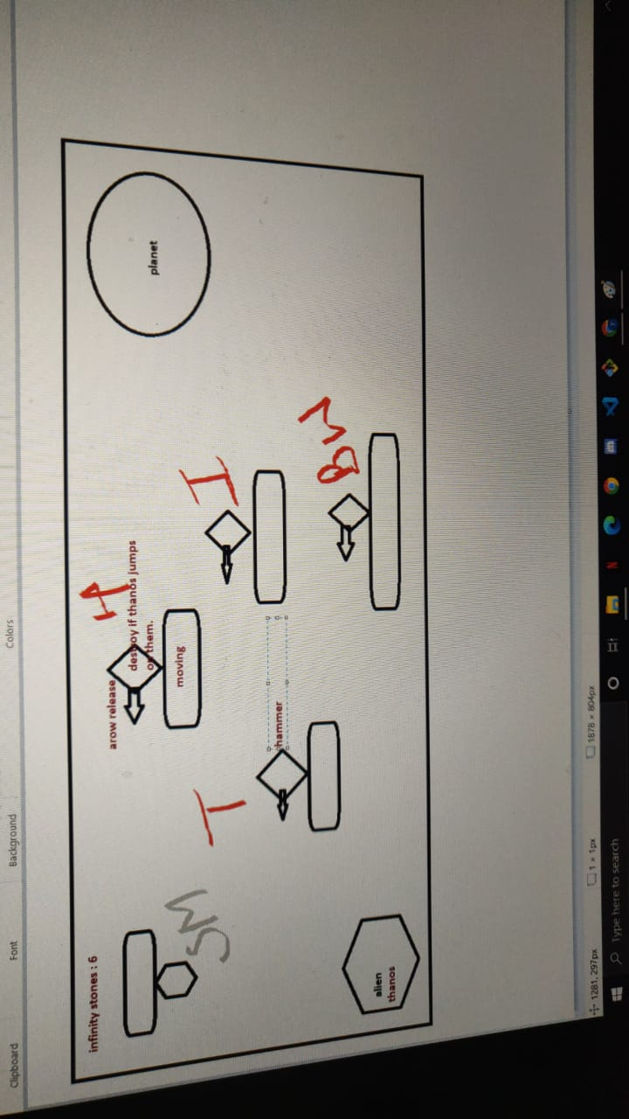

How do you plan to make your game engaging?

By adding animation